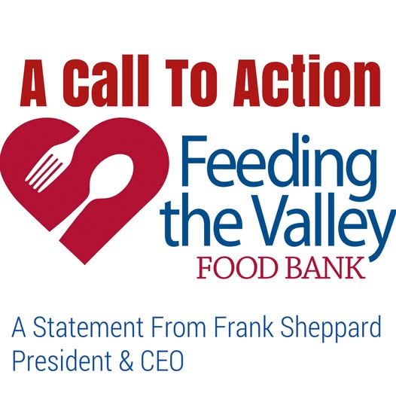

A Statement and Call to Action from Feeding the Valley Food Bank
At Feeding the Valley, we take seriously the critical role that our organization plays in food emergency response and disaster relief efforts.
Today, we are in the wake of a new emergency. With impending delays in SNAP benefits, active-duty military paychecks and furloughed government workers, our neighbors will very soon have insufficient food and will be looking to us for solutions.
The issues are not only with a sharp rise in demand, but on the supply side as well. While food banks across the country are experiencing a food shortage from several post-pandemic factors, we now have a suspension of our federal food supplies during this shutdown. The wicked combination of rise in demand and a dwindling food supply is now a reality in our world.
Rest assured that Feeding the Valley is doing everything we can and has been proactive in our approach to this event. We are scheduling additional food distributions, some of them for our military families to get them the nutrition they need. We are in touch with our network of partner agencies to help them prepare for the rise in demand. We have reached out to our local officials and will make them aware of our response plans.
As a proactive measure well before the shutdown began, Feeding the Valley launched the Community Hunger Relief Fund. This fund has a goal of raising $500,000 by the end of the year to help in our ongoing efforts to provide food assistance during these difficult times. Most of the funds will be allocated to purchasing food, which we do at a high enough volume to drive the price down to approximately 10% of the retail level. This will allow us to boost our inventory levels and provide for the spike in demand we know will exist for some time after resumption of government activities.
We need your help to reach the Fund’s goal and to provide for the community during this crisis. Please consider a donation at www.feedingthevalley.org. Your gift of any amount goes a long way to help our neighbors in need during a time when that need is rising.
We are humbled and thankful for the generous and supportive community we live in, one that truly cares for those around them. We see a strong unity of purpose in the community as we answer all the supportive phone calls and send out donation boxes for food drives. Every little bit helps, and we are grateful and appreciate your support as we make our way through this crisis.
Sincerely,
Frank Sheppard, President & CEO

